**LAB-9** – FOL(forward chaining),minimax(tic-tac-toe),Alpha-Beta(8-Queens)

Observation book:

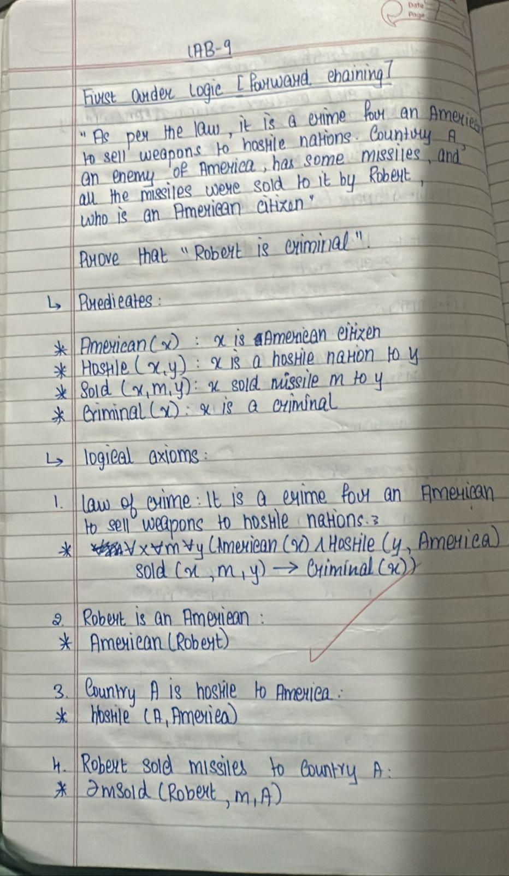

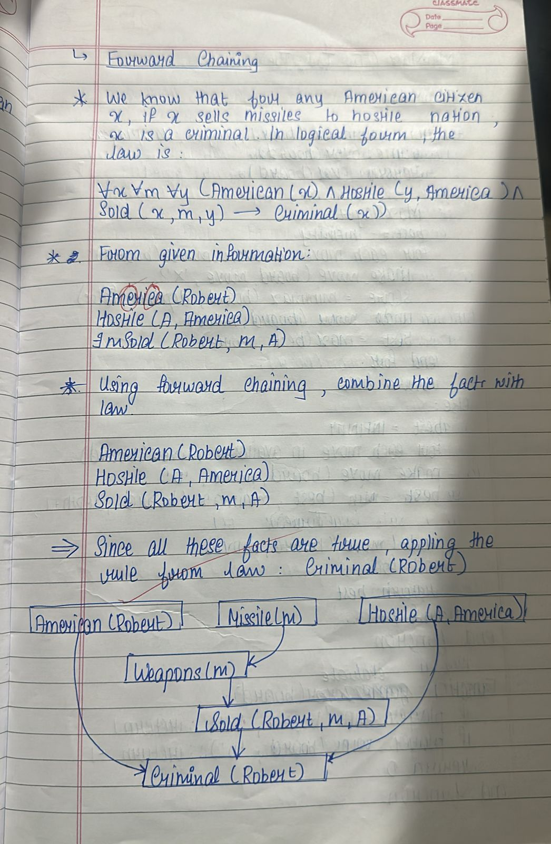

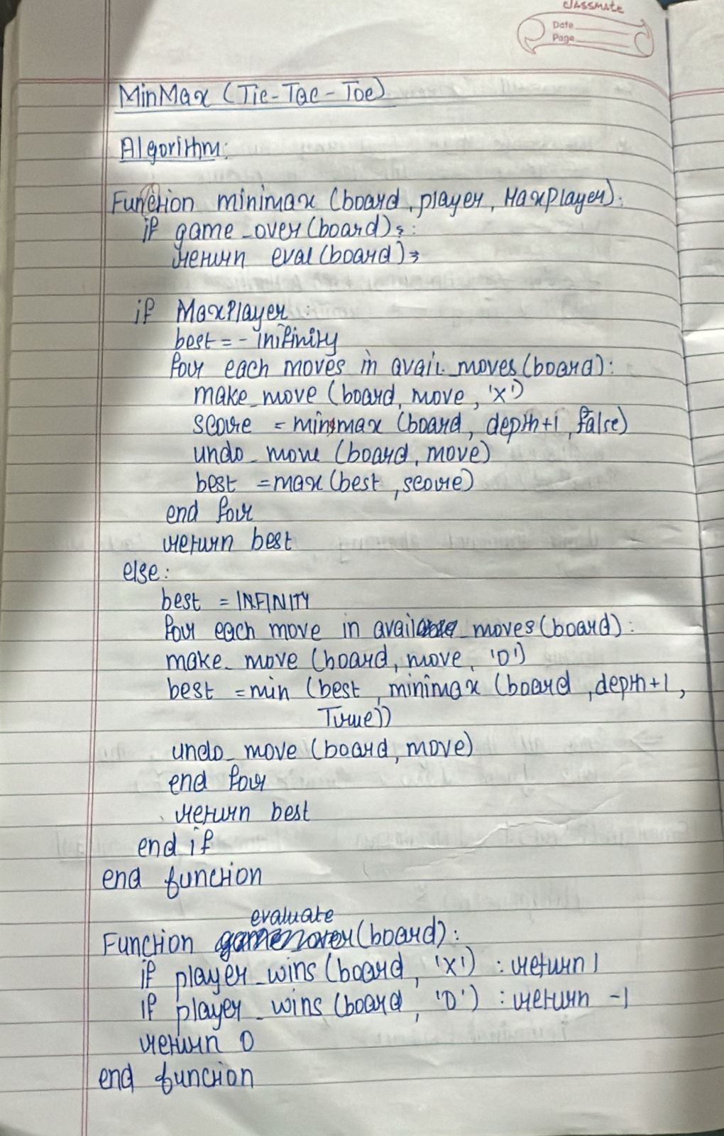

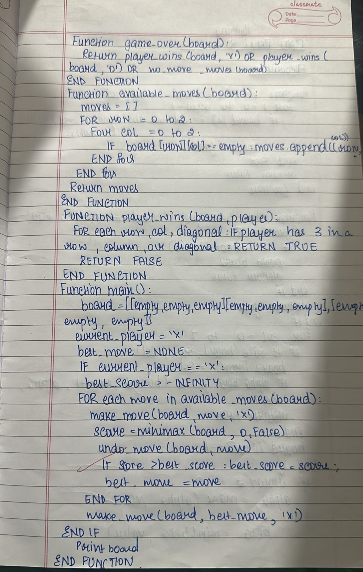

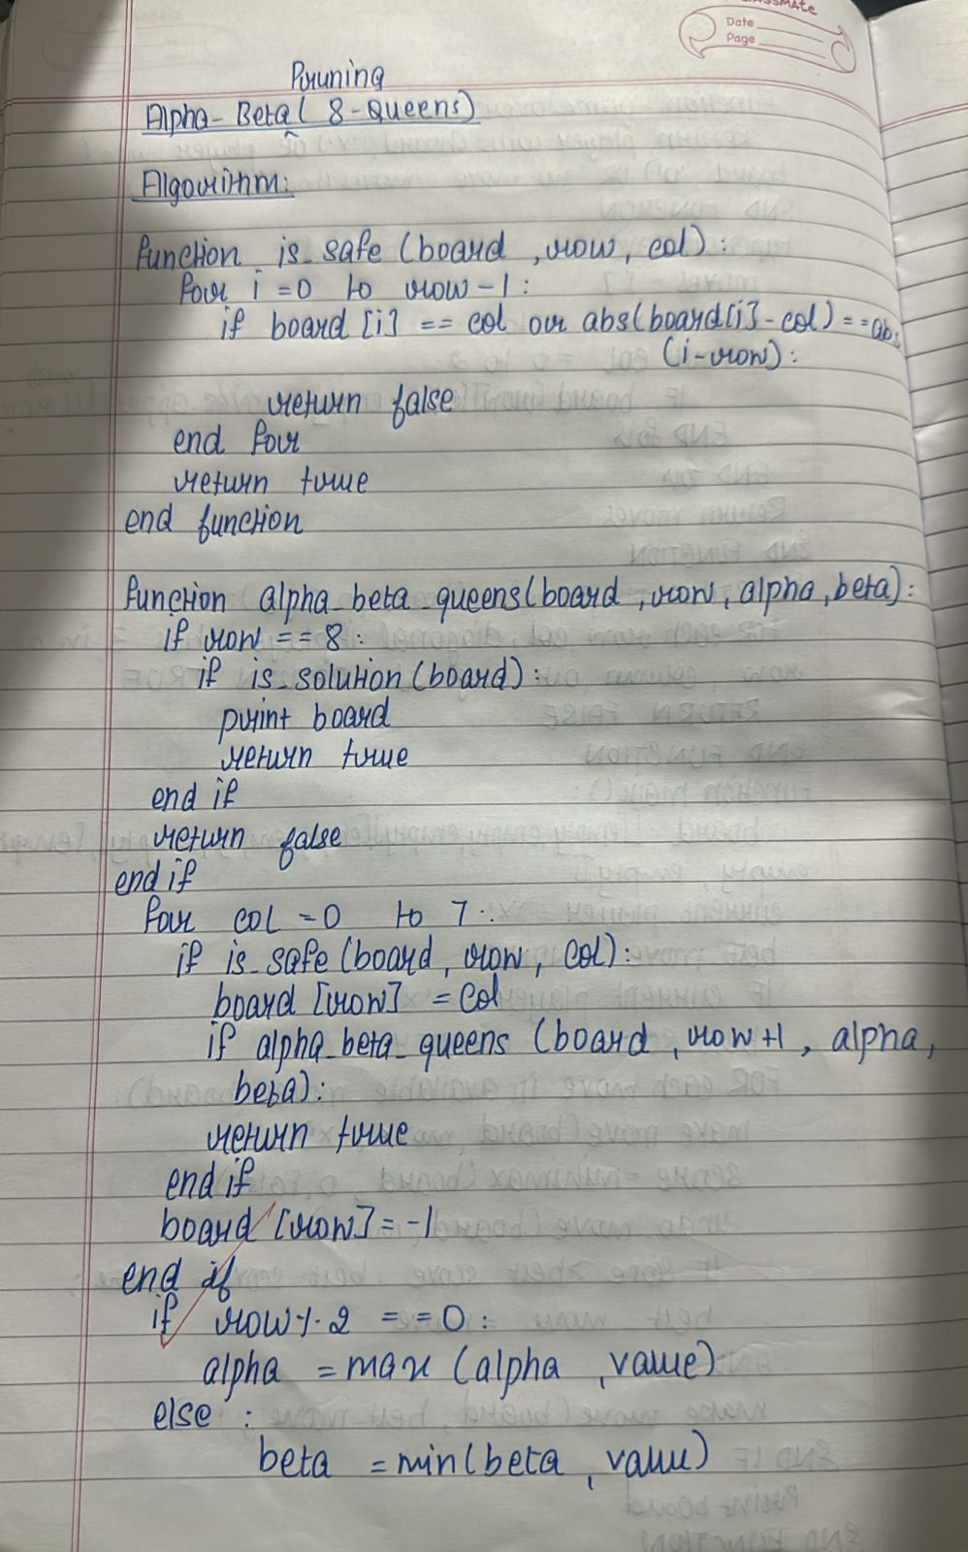

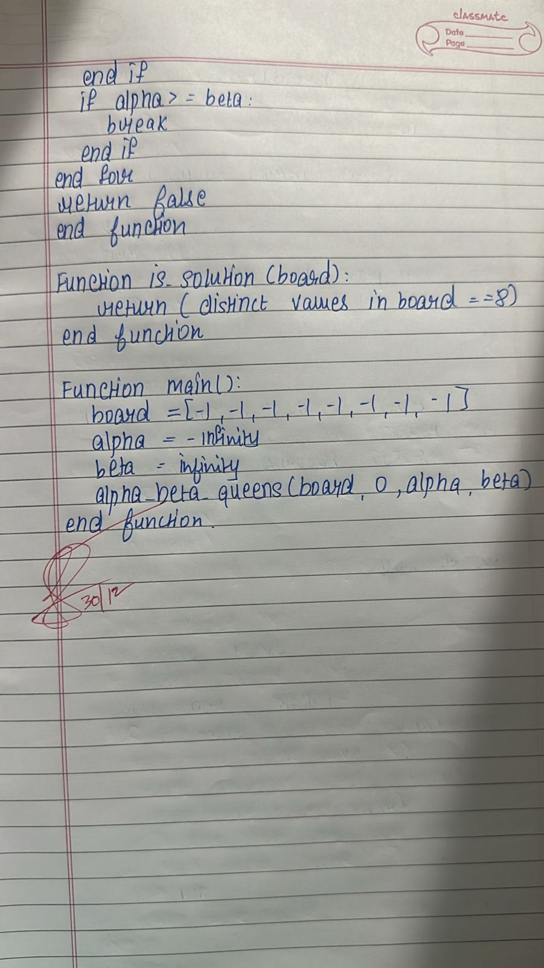

FOL forward chaining:

Code:

class Fact:

def __init__(self, predicate, *args):

self.predicate = predicate

self.args = args

def __eq__(self, other):

return self.predicate == other.predicate and self.args == other.args

def __hash__(self):

return hash((self.predicate, self.args))

def __str__(self):

return f"{self.predicate}({', '.join(self.args)})"

class Rule:

def __init__(self, conditions, conclusion):

self.conditions = conditions

self.conclusion = conclusion

def is_satisfied(self, known_facts):

return all(condition in known_facts for condition in self.conditions)

def __str__(self):

conditions_str = " ^ ".join(str(c) for c in self.conditions)

return f"{conditions_str} -> {self.conclusion}"

class ForwardChaining:

def __init__(self):

self.facts = set()

self.rules = []

def add_fact(self, fact):

self.facts.add(fact)

def add_rule(self, rule):

self.rules.append(rule)

def infer(self):

new_facts = True

while new_facts:

new_facts = False

for rule in self.rules:

if rule.is_satisfied(self.facts) and rule.conclusion not in self.facts:

print(f"Applying rule: {rule}")

self.facts.add(rule.conclusion)

new_facts = True

def display_facts(self):

print("Known facts:")

for fact in self.facts:

print(fact)

if __name__ == "__main__":

fc = ForwardChaining()

print("Enter facts (format: predicate(arg1, arg2,...)), type 'done' when finished:")

while True:

user_input = input("Fact: ").strip()

if user_input.lower() == "done":

break

try:

predicate, args = user_input.split("(")

args = args.strip(")").split(",")

fc.add_fact(Fact(predicate.strip(), *[arg.strip() for arg in args]))

except ValueError:

print("Invalid format. Try again.")

print("Enter rules (format: condition1 ^ condition2 -> conclusion), type 'done' when finished:")

while True:

user_input = input("Rule: ").strip()

if user_input.lower() == "done":

break

try:

conditions_part, conclusion_part = user_input.split("->")

conditions = []

for condition in conditions_part.split("^"):

predicate, args = condition.strip().split("(")

args = args.strip(")").split(",")

conditions.append(Fact(predicate.strip(), *[arg.strip() for arg in args]))

predicate, args = conclusion_part.strip().split("(")

args = args.strip(")").split(",")

conclusion = Fact(predicate.strip(), *[arg.strip() for arg in args])

fc.add_rule(Rule(conditions, conclusion))

except ValueError:

print("Invalid format. Try again.")

print("Performing inference...")

fc.infer()

fc.display_facts()

print("Navya 1bm22cs175")

Output:

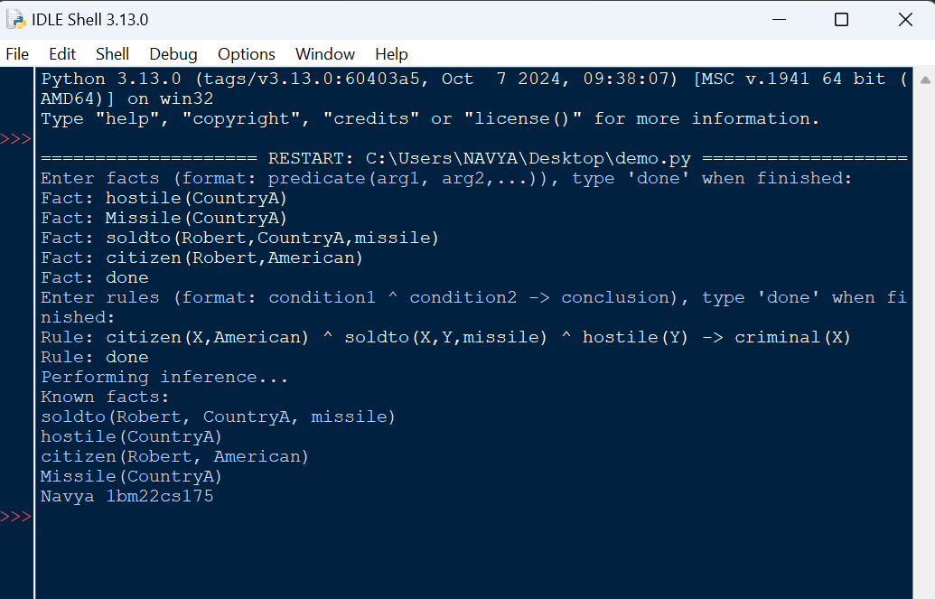

Minimax (Tic-tac-toe):

Code:

import math

def minimax(board, depth, is_maximizing_player):

if game_over(board):

return evaluate(board)

if is_maximizing_player:

best = -math.inf

for move in available_moves(board):

make_move(board, move, 'X')

best = max(best, minimax(board, depth + 1, False))

undo_move(board, move)

return best

else:

best = math.inf

for move in available_moves(board):

make_move(board, move, 'O')

best = min(best, minimax(board, depth + 1, True))

undo_move(board, move)

return best

def evaluate(board):

if player_wins(board, 'X'):

return 1

if player_wins(board, 'O'):

return -1

return 0

def game_over(board):

return player_wins(board, 'X') or player_wins(board, 'O') or no_more_moves(board)

def available_moves(board):

moves = []

for row in range(3):

for col in range(3):

if board[row][col] == " ":

moves.append((row, col))

return moves

def make_move(board, move, player):

row, col = move

board[row][col] = player

def undo_move(board, move):

row, col = move

board[row][col] = " "

def player_wins(board, player):

# Check rows and columns

for i in range(3):

if all(board[i][j] == player for j in range(3)) or all(board[j][i] == player for j in range(3)):

return True

# Check diagonals

if all(board[i][i] == player for i in range(3)) or all(board[i][2 - i] == player for i in range(3)):

return True

return False

def no_more_moves(board):

return all(board[row][col] != " " for row in range(3) for col in range(3))

def main():

board = [[" " for _ in range(3)] for _ in range(3)]

current_player = 'X'

best_move = None

if current_player == 'X':

best_score = -math.inf

for move in available_moves(board):

make_move(board, move, 'X')

score = minimax(board, 0, False)

undo_move(board, move)

if score > best_score:

best_score = score

best_move = move

make_move(board, best_move, 'X')

print("Board after the best move:")

for row in board:

print(row)

if __name__ == "__main__":

main()

print("navya 1bm22cs175")

Output:

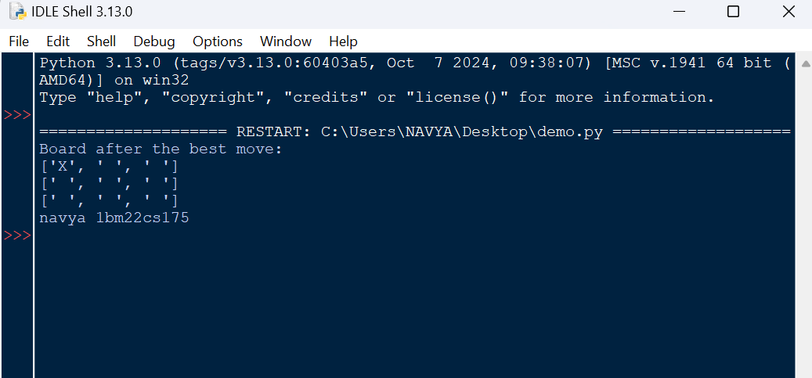

Alpha-beta(8Queens):

Code:

# Function to check if placing a queen at (row, col) is safe

def is_safe(board, row, col):

for i in range(row):

if board[i] == col or abs(board[i] - col) == abs(i - row): # Check for column and diagonal conflicts

return False

return True

# Backtracking function for N-Queens

def solve_n_queens(board, row):

if row == 8: # All queens have been placed

print_board(board) # Print the board if solution is found

return True

for col in range(8): # Try placing a queen in each column of the current row

if is_safe(board, row, col): # Check if placing a queen at (row, col) is safe

board[row] = col # Place the queen in the current column

# Recursively attempt to place the next queen in the next row

if solve_n_queens(board, row + 1):

return True # Solution found, propagate up

board[row] = -1 # Backtrack: Remove the queen from the current position

return False # No solution found in the current row and column configurations

# Function to print the board in a readable format

def print_board(board):

for row in range(8):

line = ['Q' if board[row] == col else '.' for col in range(8)]

print(" ".join(line))

print()

# Main function to start solving the N-Queens problem

def main():

board = [-1] * 8 # Initialize the board (no queens placed)

if not solve_n_queens(board, 0): # Start solving from the first row

print("No solution found.")

# Call the main function

main()

print("Navya 1BM22CS175")

Output:

